AI-Based Intelligent Hackathon Team Formation Through TF- IDF Factorization, Collaborative Filtering, and Graph Neural Network Modeling

Prachi Rani Department of CSE(AI)
Krishna Institute of Engineering & Technology(KIET), Ghaziabad, U.P.,
India prachirani455@gmail.com
Pari
Dept. of CSE(AI)
Krishna Institute of Engineering & Technology(KIET), Ghaziabad, U.P.,
India officialpari24@gmail.com
Laxman Singh
Department of CSE(AI & ML) Krishna Institute of Engineering & Technology(KIET), Ghaziabad, U.P., India laxman.mehlawat01@gmail.com

Sujal Singh Department of CSE(AI)
Krishna Institute of Engineering & Technology(KIET), Ghaziabad, U.P.,
India sujalteotia1179@gmail.com
Kartik Singh Department. of CSE(AI)
Krishna Institute of Engineering & Technology(KIET), Ghaziabad, U.P., India kartiksingh.162004@gmail.com
Rekha Kashyap
Department of CSE(AI & ML) Krishna Institute of Engineering & Technology(KIET), Ghaziabad, U.P.,
India rekha.kashyap@kiet.edu

Abstract - The TeamBuilders platform presents a very smart method for producing a well-designed team for the hackathons. This platform has AI-derived matchmaking ability. This app helps to connect people through their skill set in which they are expertise. The inbuilt AI model suggests teams that fit well, based on suitability, skill variety, and priority-based interactions. This AI model helps to enhance the efficiency of team formation. This work provided a scalable solution, elevating hackathon collaboration by using this AI model.
Keywords: AI Matchmaking, Team Formation, Hackathon Platform, Collaboration Intelligence, Graph Neural Networks.

INTRODUCTION
Finding suitable teammates with same goals, required technical skills is and big challenge [1]. Team formation problem (TFP), has been studied across different fields like education, software engineering, etc. It requires a bunch of people from bigger bunch of available candidates regarding different skills, experience, personality [2]. GNN, in particular Graph convolution networks (GCN)
[3] and graph attention networks GATs [4], can be used to design relation between participants as a graph, where node is a user, and edge between nodes describe a common technical attribute. These deep learning models are used to provide improved prediction accuracy in complex network environments. Recommendation algorithms like collaborative filtering [5], factorization machines, and graph-based learning can be further upgraded in order to increase the match making accuracy by learning hidden patterns across participants, skills and network behavior. Such up graduation allows evolution of the platform as more user interact with system, this improves team recommendation over time. Dual role
access enables participants to register and navigate through hackathons, while admin can create and organize team, this assures fair participation [6]. The complexity of this problem grows together with number of participants and applied constraints. So, it is called NP hard optimization problem [8]. Commonly use methods fail to scale efficiently. This lack of coordination results in unbalanced teams, therefore reducing participation rates and purpose of hackathons [10]. Hackathons are events that promote teamwork, creativity, and problem solving among organizations. They help to form an environment of creativity and teamwork and minimize gap between academic learning and practical implementation [15]. This paper deals with these challenges by presenting TeamBuilders, a MERN web platform that helps in automation of the process of forming teams for hackathons. The system uses the technologies of AI and ML technologies to provide a genius matchmaking of participants for organizing teams. The platform TeamBuilders collects features into its design centered on the user including real time availability of seats, linking of profiles, etc. By focusing on transparency and data driven information, this system helps build an environment that result in innovation and learning.

RELATED WORK

Lappas et al. [1] team formation has been an important topic within organizations. it needs a good combination of people who work with coordination. [1] gave one of the oldest models in a proper team selection over organizations by designing problems in a way that aims to organize teams filled with all the required roles along with reducing the communication cost. This helped for computational approaches for team formation, which led to the formation of all other methods that include real

world network dynamics. Building on this, Li et al. [2] increases team structure by using smart algorithms that can find optimal teams with respect to skills required. Their framework is based on practicality - a challenge that TeamBuilders deals with by using databases like MongoDB and Node.js for real time team formation in hackathons. Kipf and Welling [3] introduced GCNs, they are capable of designing relationships between participants using nodes interconnected based on shared skills or previous collaborations. This way, Graph Attention Networks, as introduced by Veličković et al. [4], improve efficiency to properly capture importance of relationship between different users. These models led the future scope of TeamBuilders in which AI based matching would turn into graph-based analysis of participants to recommend required teammates. Recommendation systems have proven to be good tools for mutual decision making. [5] term - weighing models by Salton and Buckley [6] tells us to how modern algorithms see items for similarity and relativeness. Su and Khoshgoftaar [7] enhanced this more by introducing a survey on collaborative filtering techniques, breaking them down into memory - based, model based, and hybrid systems. In respect to the TeamBuilders this means skill based filtering and personalized recommendations, this allow participants to find their most compatible teammates.

The work of Ciolfi et al. [8] researched algorithmic models, categorizing them according to the several objective functions, includes skill varieties, and communication potential. The Teambuilders approach ensures balanced team structures that avoid skill overlapping. Anagnostopoulos et al. [9] discuss impact and correlation problems in social networks, in team building scenarios it will determine participants who will likely collaborate based on collaboration patterns of influence.
Yu et al. [10] targeted at team formation in organizations, introducing models that update team assignments with respect to user interaction and requirements. this change organizes the real time seat availability and the team management system in TeamBuilders, making sure users seamlessly join or leave teams based on live events.
Farasat and Nikolaev [11] introduced models that stores team social structures and preferences while stressing the importance of interpersonal relationships and compatibility to technical skills. TeamBuilders works on this principle by enabling users to connect to professional profiles like LinkedIn and GitHub, this makes sure that when recommendations are shown then both skills credibility and collaboration are considered.
[12] factorization-based models like Rendle's Factorization Machines 13, allows for making more advanced and predictive recommendation engines. Gamification has also been seen as a major tool of improving engagement within organizations. Rahman et al. [14] performed a survey in which it was researched that how gamification elements like badges, leaderboards, and progress improve motivation to participate. Adding such elements within TeamBuilders makes sure that participants don't leave in hackathons and makes participation more meaningful.
[15] the main challenges: lack of visibility, skill mismatching. These findings make main purpose of TeamBuilders, which we will try to solve these issues through a web platform, AI - assisted to help whole
process of finding, forming and managing teams in hackathons.

METHODOLOGY
It uses a DDR approach, where the technology is built and then checked with users. A working prototype was shared with college students and hackathon participants. The system was developed with the MERN stack to provide a scalable platform and real-time communication for hackathon participants. They made profiles where they added their skills and what they prefer. The AI module provided recommendations for team formation. Participants gave feedback that helped improve the system’s usability and accuracy. The AI module uses TF- IDF, cosine similarity, and a GNN model to evaluate participant compatibility. The GNN represents users as nodes in a network and learns patterns such as matching skills. Quantitative data was analyzed using Python with pandas and NumPy to measure matching accuracy, response time. Qualitative feedback was used to understand user experiences and the reliability of the system.

SYSTEM ARCHITECTURE
The system is built on a modular and scalable architecture designed to support smooth interaction among participants, administrators, and the AI-driven matchmaking engine.
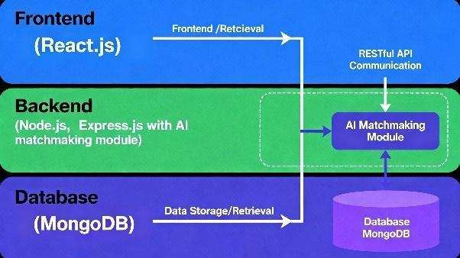
Fig. 1. Overall system architecture showing frontend, backend, and database layers.
The architecture consists of three core layers: the frontend, backend, and database, all connected through secure RESTful APIs to maintain consistent communication and efficient data flow across the platform.
The frontend layer is written using React.js and allows access to an interactive dashboard where new users are able to signup, see events, and change their profile. The users can also form or join teams. The user-friendly interface can also be updated in real-time like new team requests and event progress.
The backend was picked as Node.js and the express which will deal with the user authentication, session management and all the business logic in the form of REST APIs. The system which verifies the formation of the teams based on some criteria in which the number of team members is limited and members are assigned roles where they belong falls under the rule engine. It should also have the backend enabled with smart match making system that proposes teams on the basis of compatibility. MongoDB is chosen as the data layer on which the details about the participants of the event, skills, information about teams, event data, and so on are going to be stored. The flexible schema of the same can easily expand to accept the addition of new fields such as LinkedIn,

GitHub, or achievements and the extremely fast queries will ensure system responsiveness on a timely basis.
The matchmaking module is an important part of the system based on AI. It provides compatibility scores because it considers the skills, experience as well as preferences of each user. The system does not use simple similarity measures, but uses a GNN to demonstrate the similarities between the participants. In this model, the users are managed as each node, and common skills or prior co-operation are the connections between them. In this way, the system generates recommendations of teams considering technical competencies and the possibility of the participants to cooperate with one another. The basis of these recommendations is on the potential of good workmanship in any team and is not just limited to the capabilities that match the job but rather to the propensity of the capability working in any team. During the future employment, the system may be improved with sentiment analysis and simple personality test that, consequently, will guarantee even higher staffing and total productivity.

IMPLEMENTATION

The project is implemented in a mobilized manner in which all modules interact. All modules are particular to make the system convenient and interactive, as well as helpful to students desiring to create teams, compete, and collaborate effectively. The design is geared towards a user-friendly design, which can expand as more users are added, and which can easily coordinate among additional functionalities. Consequently, the whole system becomes one, well linked platform that is simpler and convenient to the users.
The first to be introduced will be a User Authentication and Profile Creation that will be highly secure. The learners will be in a position to log in by using their email and password. The platform retains the login sessions through JWT to improve the security of the data and the proper handling of the login sessions. Once this, the user will be able to establish profiles as per their preferences, which means to show their technical skills, preferred positions, and areas that they wish to receive assistance. It is a systematic profile creation as shown in Fig. 2 which becomes the base of AI-generated recommendations at a subsequent point.
The main part of the system is the Skill Matching and AI Recommendation Engine, shown in Fig. 3. This module uses TF-IDF and cosine similarity to check how well participants match based on their skills, and project interests. The system also looks at how users usually work together and their past collaboration behavior to calculate a better score. Based on this analysis, the module suggests suitable team members and projects, helping students connect with others who have another skill.
Its primary component is the Skill Matching and AI Recommendation Engine presented in Fig. 3. This module makes use of TF-IDF and cosine similarity to verify the level of matching of the participants of different areas of skills, and the project interests. The system also examines the way the users tend to collaborate and how they have behaved historically as a team in order to derive an improved score. Upon the analysis, the module proposes an appropriate team and project, and assists the students to establish contact with other students possessing another skill.
The Project Navigator and Role Mapping module will be used to support the different contests and projects, which produces a graph-based mapping using decision tree logics that can in turn be used to match the individual strengths of each person with the project needs and milestones. It also provides full insight into the role of every member of a project hence ensuring that the contribution is relatively balanced throughout the entire project lifecycle.
Other elements of the system are included to encourage students to participate actively with the help of progress tracking and basic gamification. The students get points and badges to participate and on the other hand there are leader boards to encourage greater interest and healthy competition. One of the examples of a heatmap like that at GitHub indicates the amount of activity every day, letting teams monitor what they are accomplishing and how it is being achieved. The features ensure that the platform is more interactive and helpful to students.
The final component of the system is Collaboration and Communication module that assists team members in being able to work harmoniously. It enables real-time chat, file sharing, as well as periodic updates on the project activities. Dependable communication APIs are employed in a way that the user is maintained in touch and informed without relying on other external tools. Regardless of whether students are talking about ideas, exchanging documents, or delegating tasks, all of this occurs within a single location. All these modules, together, form a well- structured system which will assist a student in profile making to the successful execution of projects.
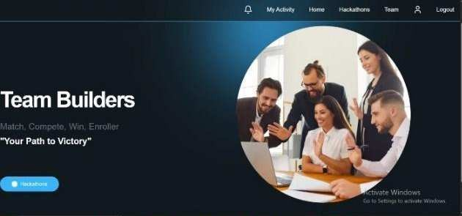
Fig.2. Illustrates the profile creation interface that allows the users to give structured information about their abilities, field interests, and co-working preferences, thereby creating the main input for the matching engine.
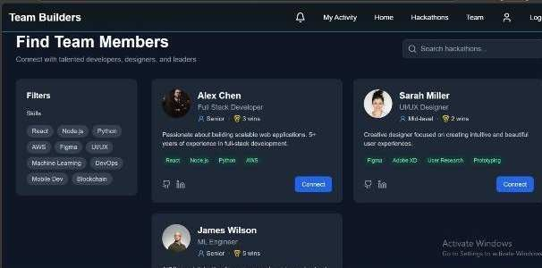
Fig.3. Skill Matching

MACHINE LEARNING INTEGRATION
Our website uses machine learning to build core intelligence behind formation of teams: flexibility, effectiveness and equity. Collaborations and multifaceted nature of participant data in hackathons have traditionally increased the capabilities of rule-driven matching teams approaches. To overcome this limitation TeamBuilders integrated machine learning system graph-based learning, collaborative filter methods and test extraction for delivering adaptive and context-sensitive matching.

Skill and Profile Representation using TF-IDF:
The technical and behavioral characteristics of participants are converted into formats through a text vectorization process, which serves as the foundation of the matchmaking engine. The skills, tools and interests listed by each participant are represented as dimensional feature vectors through TF-IDF [6].
Within the user profile d for a term t the TF-IDF weight is computed as: 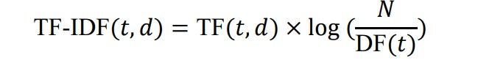
Within this context TF(t,d) signifies the frequency of term t in document d N stands for the number of user profiles and DF(t) refers to the number of profiles containing the term t. Each of the profile vectors is compared using cosine similarity, defined as:
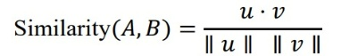

where u and v represent the TF–IDF vectors for participants A and B. This produces a similarity score between 0 and 1 enabling straightforward compatibility assessment. For example a participant, with "Python, Flask, Machine Learning" would show similarity to another participant listing "Python, Data Science, Flask " thus improving the contextual clarity and relevance of matches.

Collaborative Filtering for Personalized Recommendations:
Alongside text-based matching TeamBuilders utilizes Collaborative Filtering to uncover connections derived from past data [5] [7]. CF detects patterns, in participants previous teamwork, profile engagements and team choices; thus, the system is able to suggest teammates even when there is little direct skill similarity.
The model utilizes matrix factorization to predict a participant’s propensity to work with another person.
𝑅(𝑢, 𝑖) = 𝜇 + 𝑏_{𝑢} + 𝑏_{𝑖} + 𝑞^{𝑇}𝑝_{𝑢}where R(u,i) indicates the estimated compatibility, between user u and teammate i,
𝑖
𝜇 stands for the average, 𝑏_{𝑢}and 𝑏_{𝑖} are bias components and 𝑞^{𝑇}𝑝_{𝑢} represents latent factors capturing hidden user- team relationships. Moreover, factorization machines can be utilized to handle sparse feature matrices while capturing complex pairwise feature interactions. In addition to ensure user’s data expansion, it is scalable, reliable as per events.
𝑖

Graph Neural Network Modeling:
Graph Neural Network (GNN) is utilized as per the framework for modelling and forecasting team compatibility among team members. We represented participants and their interactions on a graph structure efficiently both characteristics and relationships in between participants. Nodes are representing individuals within the graph and the links or edges between these nodes that carry weighted data reflecting skills intersections, domains and previous collaborations, and previous experiences among the participants. This allows the model to go beyond tabular connections and grab dynamically and effects within a team’s network. Each node 𝑣_{𝑖} the graph is associated with a feature vector 𝑥_{𝑖} = ["𝑠𝑘𝑖𝑙𝑙𝑠, 𝑒𝑥𝑝𝑒𝑟𝑖𝑒𝑛𝑐𝑒, 𝑑𝑜𝑚𝑎𝑖𝑛, 𝑐𝑜𝑙𝑙𝑎𝑏𝑜𝑟𝑎𝑡𝑖𝑜𝑛 𝑠𝑐𝑜𝑟𝑒"].
The technical profiles of every participants joins these characteristics. The e_ij edges links the nodes and are established based on 2 criteria: (1) cosine similarity to participants skill vectors, which evaluates the match of their own technical abilities and (2) the count of part interactions or collaborations are among participants indicating their history teamwork. The result, consequently being captures the expertise distribution and the relational dynamics among users forming an insightful teamwork, for learning. The GG suggestions enables the dissemination and accumulation of features, across graph. The GCN functions can be precise; y expressed as: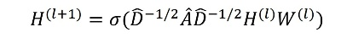

where D represents the associated degree matrix, H(l) stands for featuring matrix at the I-the layer W(l) denotes a notable weight matrix is a nonlinear activation such as ReLU and A = A + I is adjacency matrix of the graph, with self-loops added that ensuring each node incorporates its own features during the update process. This method of propagation allows the model to progressively collect information from every node and refine it until the representation of every participant is context-sensitive, by shaping the attributes of the participants they link to. By this way the initial GCN layer collects information from the neighbors reflects how direct connected participants affect each others. Effectively uncovering more complex relationships, within the analyzed network of users. Consequently, models can be identify crucial patterns, how skill variety and experience complement each other to facilitate the successful collaborations. For each and every pair or group of individuals, the GCNs linked output layer forecasts a compatibility score to normalized between 0 and 1. This is representing the probability that a particular arrangement would collaborate effectively to reach to high performance. The Mean Squared Error loss function is employed to evaluate the difference between the network’s score compatibility and actual performance outcomes, this is throughout the training. GNN captures a representation of the core elements influencing the alignment and experience diversity balance by steadily reducing this loss alongside interpersonal cooperation metrics in effective teamwork of user. Summarizing the project will utilize the Graph Neural Network model as mechanism, for team creation or formation. Retention of Users: Throughout the 3-week trail period of a college- based event, user's involvement was tracked to assess the engagement levels on different parameters. Using dashboards direct suggestion and teamwork monitoring, by teambuilders participants interaction was steadily upheld. 65% revealed increment in active profile visits, each growing by 1.8 times. Furthermore, the completion rate of creating or forming team may improved from 56% when done traditionally to 84% with the use our Team building website. These stats shows that AI-driven recommendations boosted user's involvement while reducing the time period required for assembling a team.. Recommendation Suitability and Team Composition: To determine the relevance of AI-generated suggestions the teams created on the platform were analyzed for diversity in skills and overall balance. To prevent any team from being excessively uniform or skewed factors such as experience, interests and skill sets were reviewed. Mentors and faculty evaluators gave the team composition a rating of 4.4 out of 5. They emphasized that the team's roles were more evenly distributed and that the members' skill sets

were more varied. Users added that when the team's makeup was determined by both behavioral and technical compatibility, meaningful collaboration tended to occur more readily.
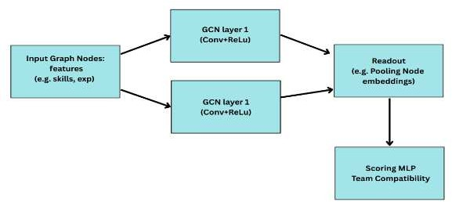

Fig. 4. Model architecture of the proposed GCN-based compatibility predictor.

RESULTS AND DISCUSSION
The evaluation of our TeamBuilders website involved a structured performance on 80 students from various engineering traits who have applied this platform for team formation according to their need and project-based events.

Team Match Accuracy:
We will compare the AI-generated team matches with expert-curated groupings. Using the GNN model, participants will be analyzed based on their skills, experience, and domain interests to predict optimal teammate or member combinations. Indeed, the results will indicate that the system was able to identify participants with required skills and collaboration patterns quite effectively, maintained a match ability of 87%. More importantly, the GNN-based prediction outperformed the t manual selection by almost 20%, that is confirming the model can identify deeper relational and necessary features that are typical for successful team formation.

User Engagement and Retention:
To increase the engagement percentage, visitors’ activity was tracked during the pilot run of a college-based event for number of weeks. Participants shown interest consistently with the integration of user-friendly dashboards, profile-based suggestions, and collaboration tracking by using website. Results show 65% of daily active users, including profile visits, connection requests, and messages. Also, rates of complete team formation increased from 56%, when it was done manually, to 84% when TeamBuilders were deployed. Our statistics reports confirms that AI-based recommendations greatly improved students’ participation while reducing the time required for balanced team formation.

Recommendation Relevance and Team Balance:
These teams, subsequently formed on the platform, needed to be analyzed in terms of skill diversity and balance to determine the relevance of AI-suggested recommendations. Their skills, interests, and experience levels were reviewed to make sure no team would become overly homogeneous or unbalanced. The average rating of the mentors and faculty evaluators regarding the quality of the team composition was 4.4/5. They underlined that the
skill variety of the members was higher, with the roles inside the team being more evenly distributed. Users added that meaningful collaboration tended to happen more easily when the composition of the team was based on both technical and behavioral compatibility.
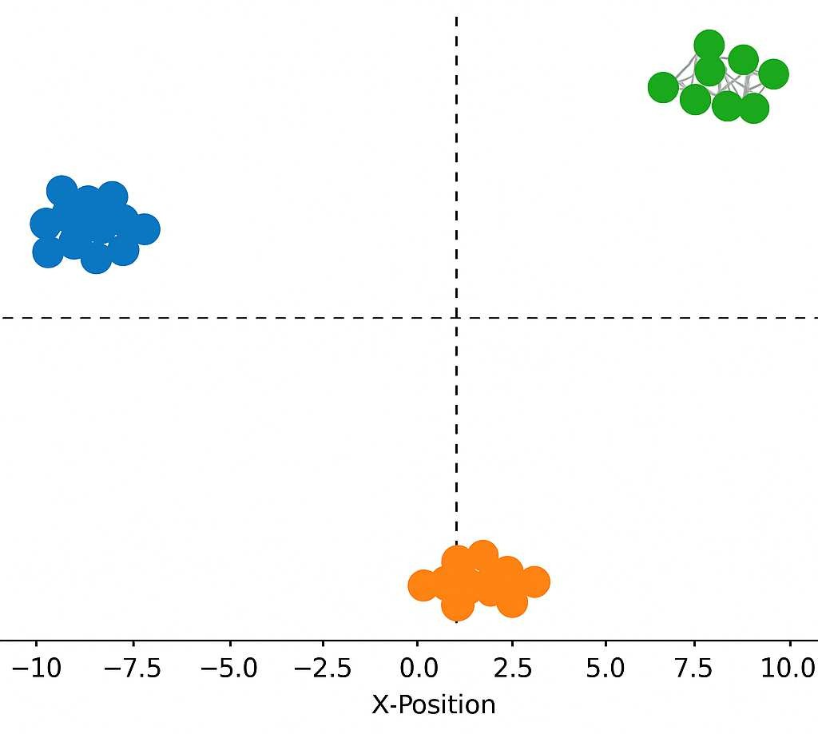
Fig.6. Shows latent skill clusters and relationships
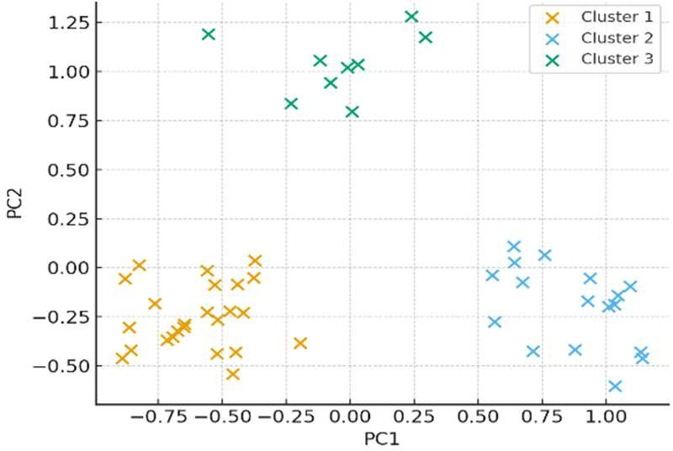
Fig.7. Visualizes learned feature separation and skill compatibility

Performance Metrics and System Efficiency:
Multi-user load simulation was done for testing the performance of the Python ML layer and the Node.js backend layer built along with Express.js.

Metric | Performance Value
Match Accuracy | 87%
Precision | 85%
Recall | 84%
F1-Score | 84.5%
Average Response Time | 1.9 seconds
Server Uptime | 99.1%
Database Query Success  Rate | 98.5%

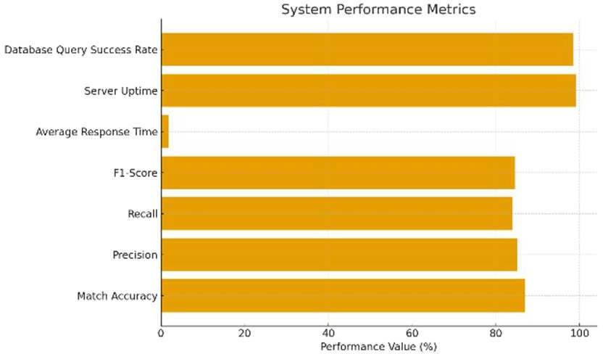
Fig.8. System Performance Metrics
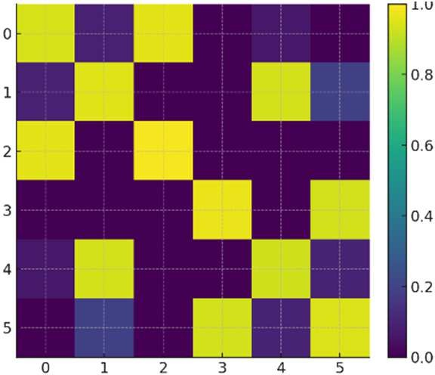
Fig.9. Represents pairwise similarity and validates quantitative results

CONCLUSION AND FUTURE SCOPE
As a matter of fact, the importance of the Participant Compatibility Prediction System in encouraging teamwork and effectiveness within teams is normally realized within academia and professional project settings. The TeamBuilders integrate machine learning algorithms that apply data-driven acknowledgement to identify participant compatibility based on skills, interests, and behavior patterns along multiple dimensions. The 2D scatter plot visualization interprets the relationships between participants; hence it provides administrators and students with a means of insight values into grouped dynamics and informed decision-making in the process pf team formation. This is visually easier and more transparent for decision-making while analyzing the distribution and requirements patterns of participants or students. Compatibility analysis and scatter plot represents the performance of the system, AI matchmaking can reduce conflicts and make great collaborations. Beyond this, the project clears a vision to collaborative AI tools that is good in both educational and organizational systems where the formation of prefect team will affect the outcome of project or competition. This project is totally future scope via predictive model by incorporating advanced deep learning neural networks that raise both the accuracy and adaptability of the models diversely. NLP integration enables the system to study participant’s profile , resumes, or past project reports in detail for better understanding of each user. Feedbacks from real and active users can introduce the capability scores by continuous learning from real performance and collaboration results. If integration of active university portals or professional networking systems , would enhance its accessibility and usability. The project created an intelligent data-driven human collaboration and teams skill-alignment with respect to emotional and behavioral
compatible for future success and harmony in their collaboration outcomes.

REFERENCES
- D. L. Lappas, K. Liu, and E. Terzi, “Finding a team of experts in social networks,” Proc. VLDB Endowment, vol. 2, no. 1, pp. 718–729, 2009.
- L. Li et al., “Enhancing team composition in professional networks: problem definitions and fast solutions,” IEEE Trans. Knowl. Data Eng., vol. 29, no. 3,
pp. 613–626, 2016.
- T. N. Kipf and M. Welling, “Semi-Supervised Classification with Graph Convolutional Networks,” ICLR, 2017.
- P. Veličković et al., “Graph Attention Networks,”
ICLR, 2018.
- B. Sarwar, G. Karypis, J. Konstan, and J. Riedl, “Item- based collaborative filtering recommendation algorithms,” Proc. WWW, 2001.
- G. Salton and C. Buckley, “Term-weighting approaches in automatic text retrieval,” Inf. Process. Manag., vol. 24, no. 5, pp. 513–523, 1988.
- X. Su and T. M. Khoshgoftaar, “A survey of collaborative filtering techniques,” Adv. Artif. Intell., 2009.
- G. L. Ciolfi, P. S. S. Cardoso, and F. Buccafurri, “Algorithmic team formation: models and techniques,” ACM Comput. Surv., 2021.
- J. Anagnostopoulos, R. Kumar, and M. Mahdian, “Influence and correlation in social networks,” Proc. ACM KDD, pp. 7–15, 2008.
- P. L. Yu, D. Zhang, and C. Li, “Team formation in online communities: models, algorithms and applications,” IEEE Access, 2020.
- A. Farasat and I. Nikolaev, “Capturing team social structure for improved team formation,” (Conference reference—verify venue for final manuscript).
- K. He, X. Zhang, S. Ren, and J. Sun, “Deep Residual Learning for Image Recognition,” Proc. IEEE CVPR, 2016.
- S. Rendle, “Factorization Machines,” Proc. IEEE ICDM, 2010.
- A. M. Rahman, U. Farooq, A. R. Hossain, and M. A. Aziz, “A survey of gamification techniques for online learning and engagement,” IEEE Access, 2021.
- E. J. Yeh, S. Rieffel, and M. Abreu, “Empirical studies on hackathon team formation and outcomes,” CHI Workshop / IEEE-style paper, 2019.

